Digital Egypt Pioneers Initiative رواد مصر الرقمية
Round 4 الدورة الرابعة
2025 - 2026 2025 - 2026

Track: AI & Data Science - Microsoft Machine Learning Engineer
Group Code: ONL4_AIS2_S7
Instructor: Eman Elgalad
Company Name: Skills Dynamix



Project Name

"AI-Powered Predictive Maintenance for Industrial Equipment"
No. | Name
1 | Moaz Osama Esamil Hataba (TL)
2 | Abrar Ashraf Shaban Ahmad
3 | Marwan Muhammad Darwish Ammar
4 | Yussef Ahmad Muhammad Elshamy
5 | Salma Muhammad Nageh Abdul-Hamid
6 | Nour-Eldin Kamel Muhammad Hasanein

Task |  | Page No. | Evaluation
Data Flow Diagram (DFD) |  | 5
Sequence Diagram |  | 7
Activity Diagram |  | 13
State Diagram |  | 19
Class Diagram |  | 20

System Analysis
&
Design
Data Flow Diagram (DFD):
- DFD Level 0 (Context Diagram)
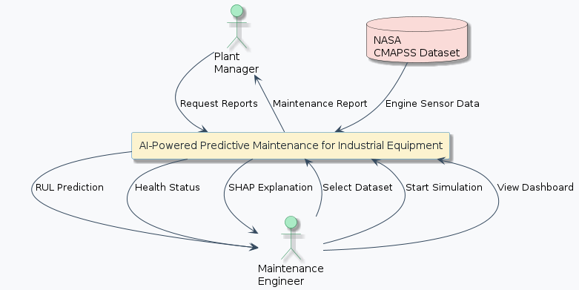
- DFD Level 1
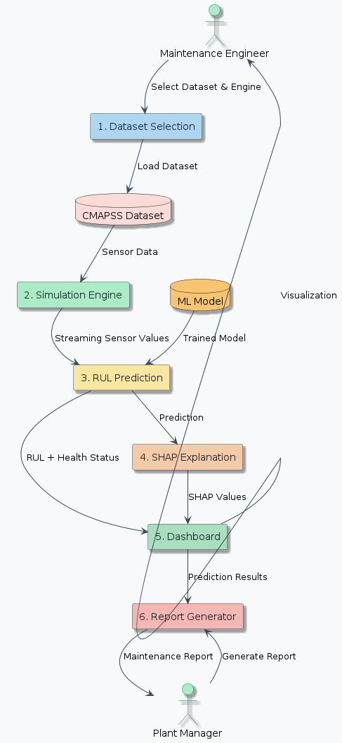
Sequence Diagram:
- Sequence Diagram 1 — Dataset Selection & Simulation
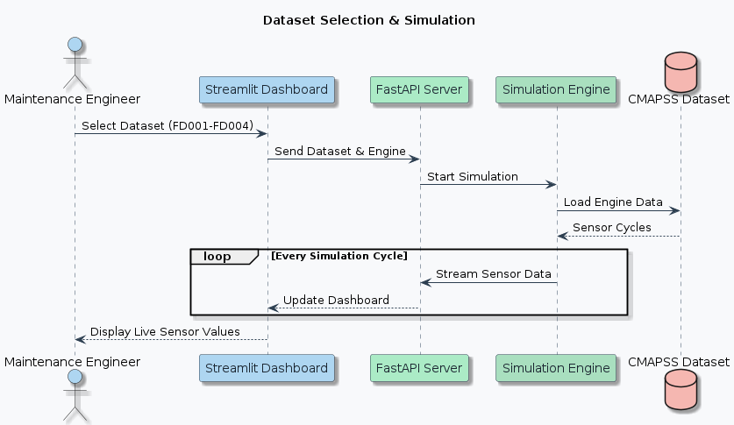
- Sequence Diagram 2 — RUL Prediction & SHAP Explanation
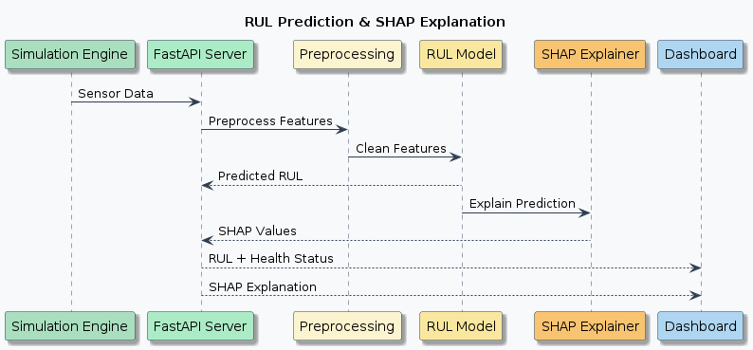
- Sequence Diagram 3 — Generate Report
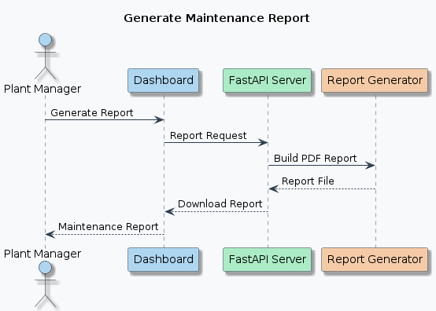
- Sequence Diagram 4 — Maintenance Engineer
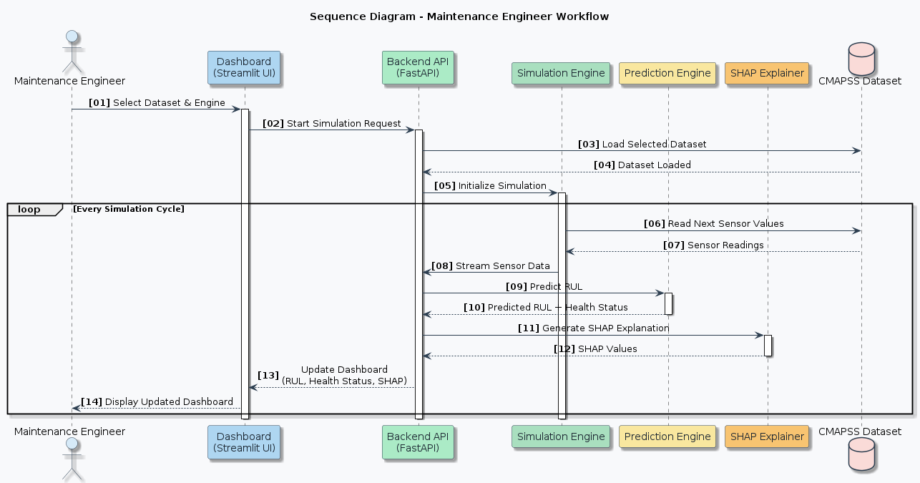
- Sequence Diagram 5 — Plant Manager
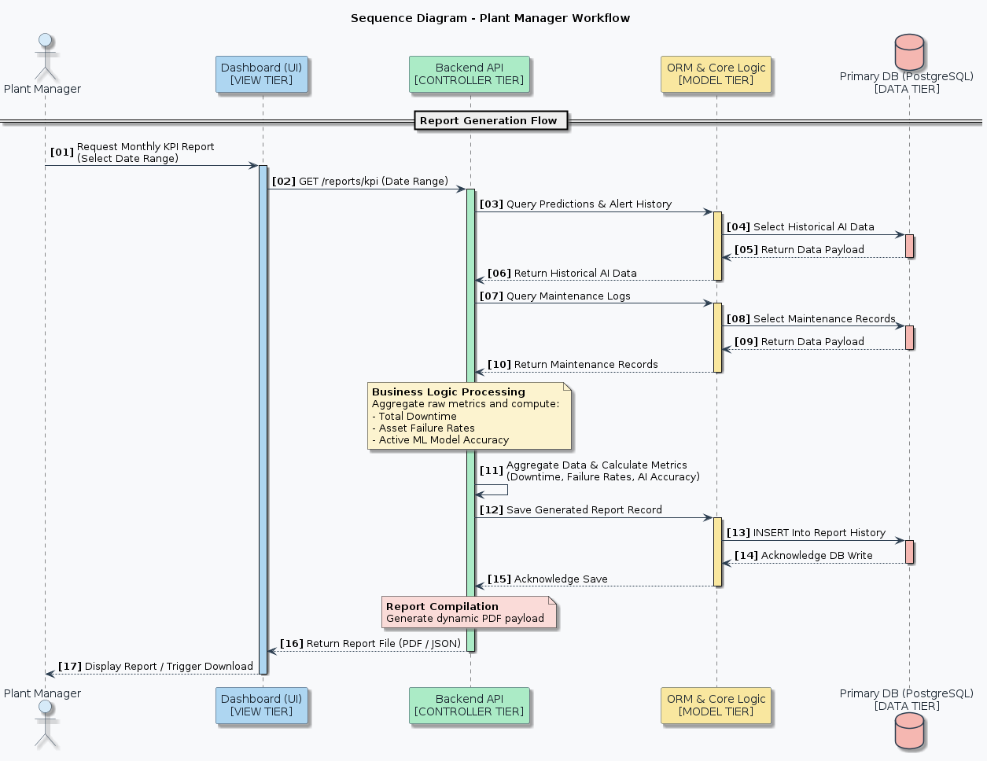
- Sequence Diagram 6 — System Administrator
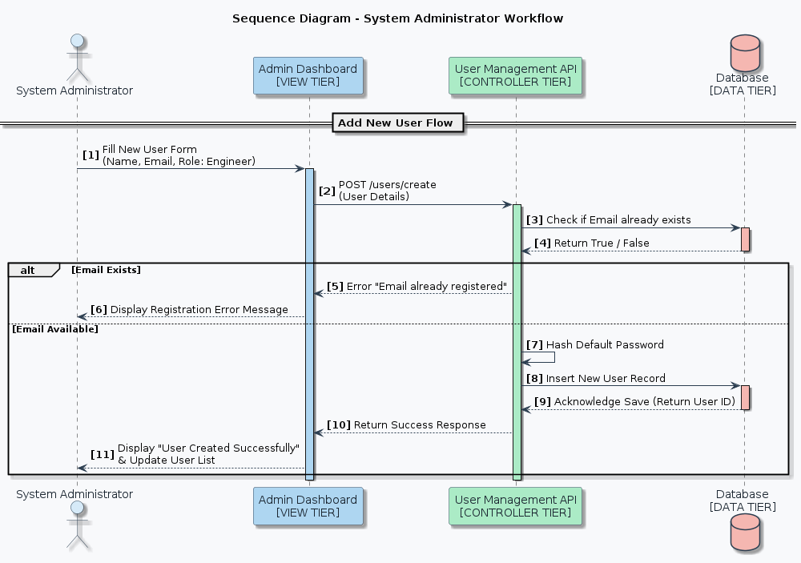
Activity Diagram:
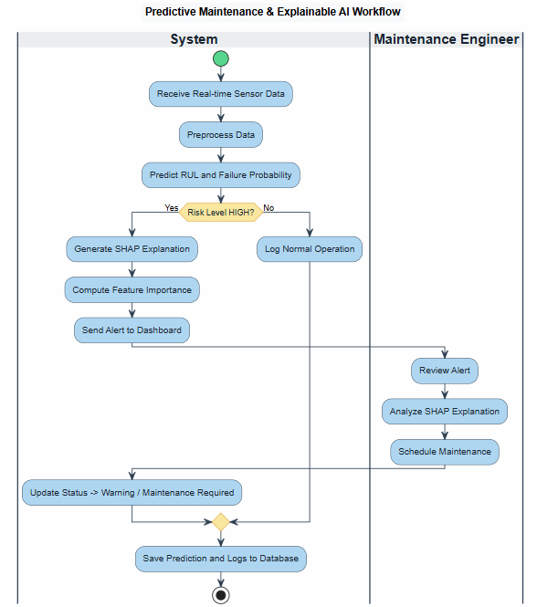
- Activity Diagram 1 — Predictive Maintenance

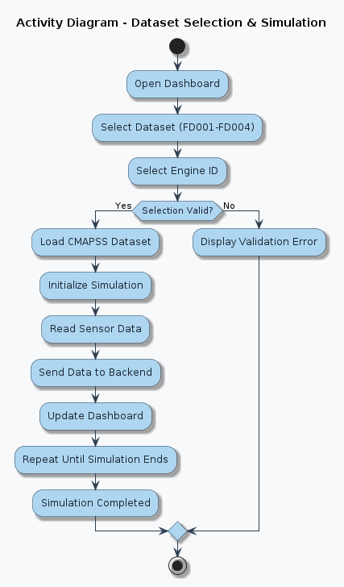
- Activity Diagram 2 — Dataset Selection & Simulation

- Activity Diagram 3 — RUL Prediction
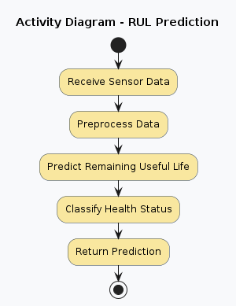
- Activity Diagram 4 — SHAP Explanation
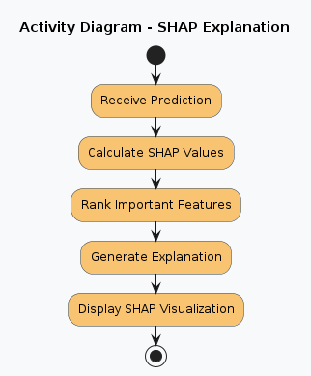
- Activity Diagram 5 — Historical Data Analysis
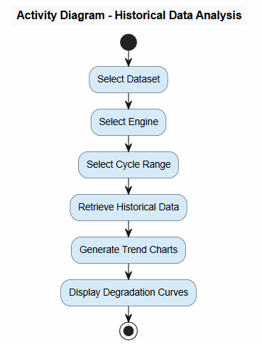
- Activity Diagram 6 — Report Generation
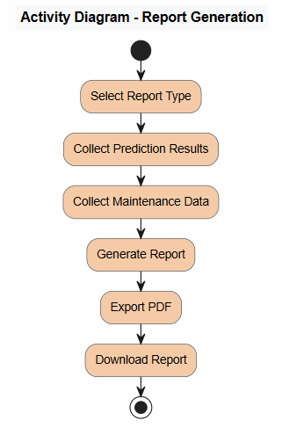

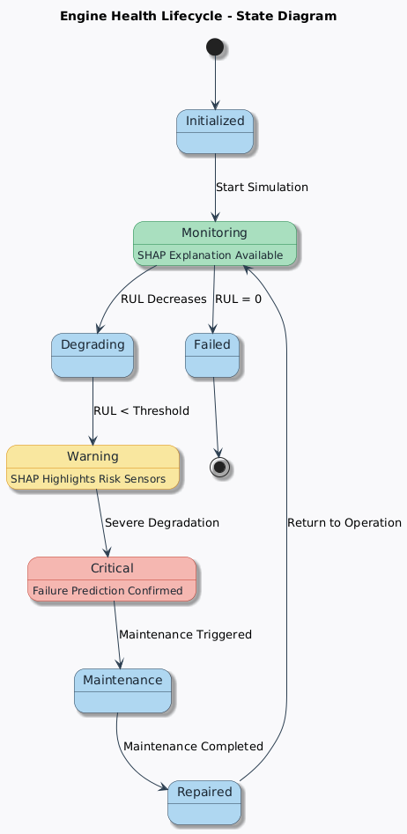
State Diagram:
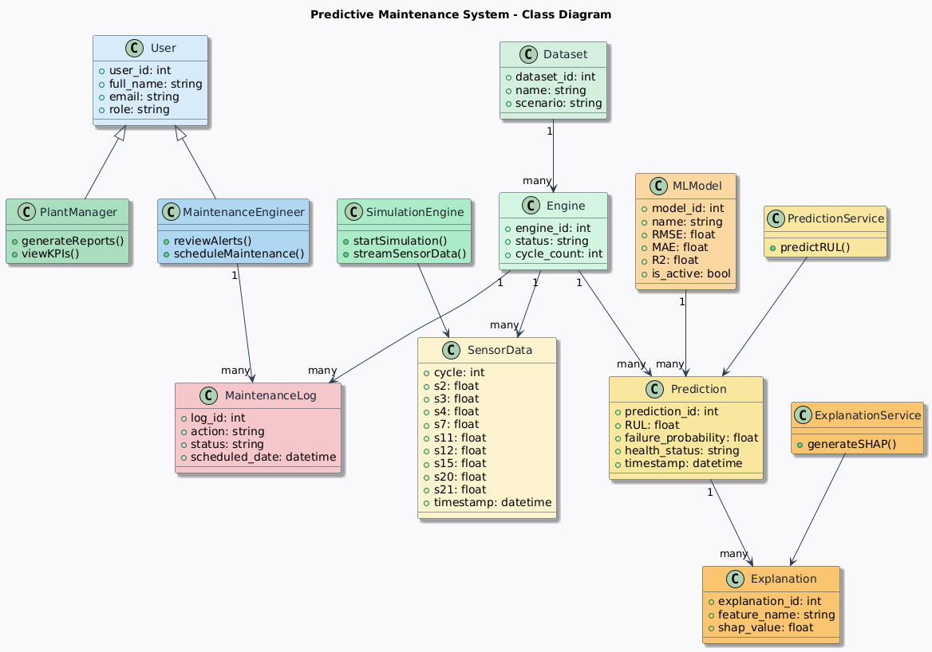
Class Diagram:

